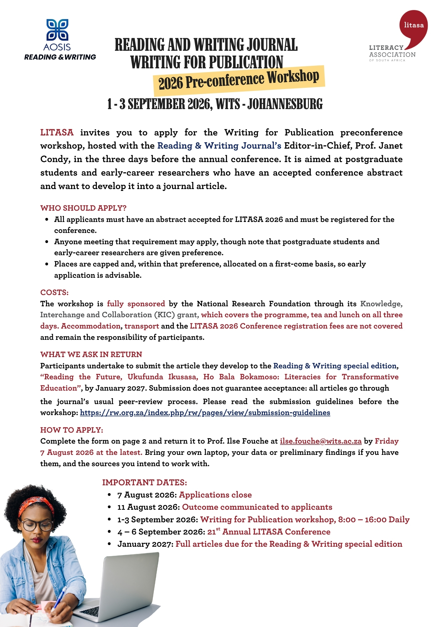

APPLICATION FORM
Writing for Publication preconference workshop, 1 – 3 September 2026
Please read the submission guidelines before the workshop:
https://rw.org.za/index.php/rw/pages/view/submission-guidelines

Complete this form and email it to ilse.fouche@wits.ac.za by Friday 7 August 2026, or as soon as you are able to. The form expands as you type.
SECTION A: YOUR DETAILS
Title, name and surname
Institution and department
Email address
Contact number
Current position | ☐ Master’s candidate  ☐ Doctoral candidate  ☐ Postdoctoral fellow  ☐ Early-career academic  ☐ Other (please specify):
If you hold a doctorate, year of completion | Leave blank if not applicable
SECTION B: YOUR CONFERENCE ABSTRACT
Title of accepted abstract
Conference strand
Registration status | ☐ Registered for LITASA 2026  ☐ Registration in process
Accepted abstract | Paste your accepted abstract here, as submitted.
SECTION C: PROGRESS TO DATE
Data collection | ☐ Not yet begun  ☐ In progress  ☐ Complete  ☐ Not applicable (conceptual or review article)
Writing | ☐ Not yet started  ☐ Notes and an outline  ☐ Partial draft  ☐ Full draft
What do you hope to achieve during the three days? | Approximately 100 words.
SECTION D: DECLARATION
☐ I undertake to submit my article to the Reading & Writing special edition by January 2027, and I understand that publication remains subject to peer review.
☐ I am registered, or will register, for the LITASA 2026 conference, and I understand that registration fees, transport and accommodation are not covered.
☐ I will attend all three days and will bring my own laptop.
Signature: ______________________________ Date: __________________

